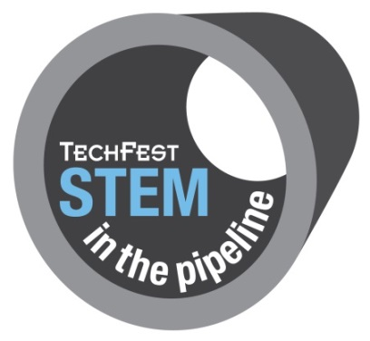

Guidance Notes for Schools 2018

Contact: Martha Gavan
Email: marthagavan@techfest.org.uk
Tel: 01224 273955
STEM in the Pipeline 2018
STEM in the Pipeline was developed in 2006 by TechFest in conjuction with industry professionals. The project was designed to enable teams of pupils to apply their knowledge of school subjects to a realistic industry project and gives an overview of the variety of job roles available in the Oil and Gas industry. The purposed project is a challenging one – to produce a Field Development Plan. For extra guidance and a real life insight to the industry, pupils consult with a mentor team of professionals. The support that is provided by the industry professionals is extremely valuable and pupils are expected to be similarly committed.
Participating pupils should ideally have achieved two Highers in Physics, Maths or Chemistry. As such, the project is primarily aimed as S6 students, although S5 students may also be considered. STEM in the Pipeline provides a great introduction to those who are interested in a career in geology, engineering, science and/or the oil and gas industry. In addition, students that are interested in other disciplines develop valuable transferable skills that are hugely beneficial to any career path.
Key Dates for STEM in the Pipeline 2018:
- Introduction Day: Thursday 6th September, Fraser Noble Building, University of Aberdeen
- Project Submission Date: Wednesday 28th November, delivered to TechFest, Butchart Centre
- Presentation Day: Tuesday 11th December, BP North Sea Headquarters, Dyce

The application form must be completed and returned by Thursday 21st June 2018 and confirmation of your school’s place on the project will be sent out to schools by Thursday 28th June 2018. We do not require the names of the students participating or photographic permission forms until Thursday 23rd August but the sooner we can get them the better.
Please note: places are limited and schools will be allocated a team on a first come first served basis.
Disclosure Scotland
TechFest supports disclosure for all people who work with schools; however we cannot confirm that all presenters have been through the disclosure process. Schools should make their own risk assessment and ensure that members of the teaching staff are present throughout all presentations.
Please note: Teachers are expected to remain with the group at all times.
STEM in the Pipeline 2018
Part 1: Introduction Day – Thursday 6th September, University of Aberdeen
This is a full and busy day introducing the teams to the oil and gas industry and the project tasks.

Industry professionals and academics present a series of lectures and workshops in geology, drilling and reservoir, finance, processing, and project management. These workshops have been developed to inform and encourage the student teams throughout the day.

The pupils will work together in their teams. They will have the opportunity to learn from friendly, experienced professionals and will gain confidence as they complete a series of practical activities. Through these activities they will find out each other’s strengths and begin to identify weaker areas.

During the Introduction Day time is set aside for the school teams to meet the industry mentors who can help them during the project. What help can be offered and how to establish a reliable method of communication are two things addressed here. At the end of the day the project materials are distributed to the teams.

Part 2: Project Work at School – September to December
The project consists of 4 consecutive tasks. Each pupil is expected to be knowledgeable and involved in each task. An approximate time to spend on each task is given. Overall each team member will spend at least 40 hours on the project, in most cases more.
The project work is challenging; teamwork, good communication, project planning and regular meetings are essential. Research and investigation will also be necessary in order to make informed decisions. Throughout the course of the project the students will need advice, support, guidance and reassurance from their assigned mentors.
A project report is to be written detailing all of the students work and results. Three hardcopies and one electronic copy must be submitted to TechFest by the deadline date Wednesday 28th November. Late entries will not be considered.
The reports are forwarded by TechFest to the panel of assessors for their appraisal. This leaves the teams a couple of weeks to prepare for Part 3.
Part 3: Presentation Day – Tuesday 11th December, BP North Sea Headquarters
This is the opportunity for the teams to give a presentation and display a poster of all their hard work. The atmosphere is very supportive. Each team has a display board and table top space for any models or additional resources. A group of assessors will visit each team for a brief presentation and interview. Invited guests and resident industry professionals offer further encouragement and advice to the students with informal discussions. The day concludes with the prize giving and participation certificates.

STEM IN THE PIPELINE – Increasing Pupils Confidence & Skills
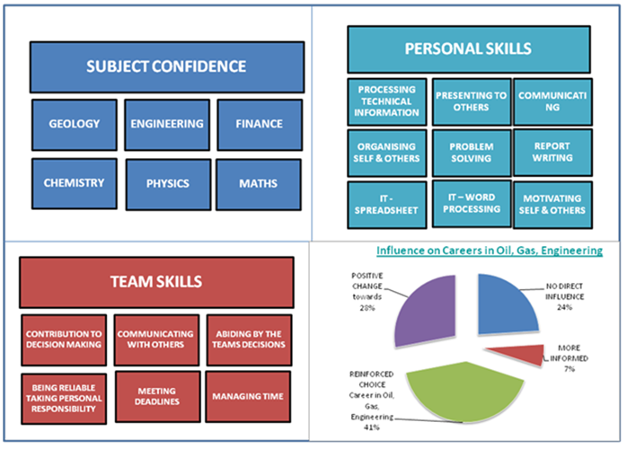

On completing STEM in the Pipeline, previous students commented:

“It was an amazing experience!”
“Helped to explain the “bigger picture” of the tasks so we could understand how our work would be more useful – and understand the industry more.”
“It has cemented my decision to be a Geoscientist”
“Taking part in this project has made me realise I would like to work in the engineering sector”

